Download the latest Packer Tracer for Linux. This example uses: PacketTracer_800_amd64_build212_final.deb

cd Downloads

sudo chmod +x PacketTracer_800_amd64_build212_final.deb

sudo apt-get install ./ PacketTracer_800_amd64_build212_final.deb

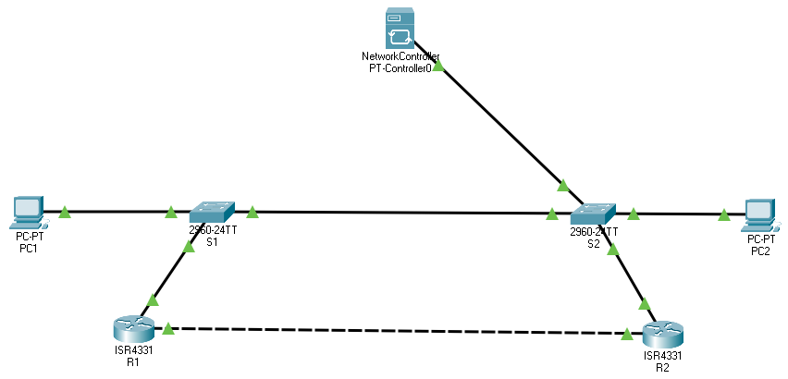

|  |  |  |  |
| --- | --- | --- | --- |
| Device Name | Type | IP Address | Subnetmask |
| R1 | Router | 192.168.1.1 | 255.255.255.0 |
| S1 | Switch | 192.168.1.2 | 255.255.255.0 |
| R2 | Router | 192.168.1.3 | 255.255.255.0 |
| S2 | Switch | 192.168.1.4 | 255.255.255.0 |
| PC1 | PC | 192.168.1.100 | 255.255.255.0 |
| PC2 | PC | 192.168.1.200 | 255.255.255.0 |
| PT-Controller0 | Network Controller | 192.168.1.10 | 255.255.255.0 |